Q1) Create an empty array and fill it with 3 elements using NumPy method.

Q2) Create a 2 dimensions array filled with ones using NumPy method.

Q3) Create the array below using NumPy and check if your array has a specific row

1,2,3,4

5,6,7,8

9,10,11,12

# Q4) Create an array using NumPy and Find the number of occurrences of a specific sequence.

# Q5) Find the most frequent value in a NumPy array.

# Q6) Build an array of all combinations of two NumPy arrays

Q7) Check whether your NumPy array has a specific value.

Q8) Flatten a matrix using NumPy.

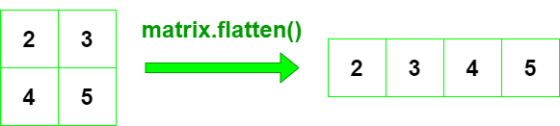

# Q9) Create an array using NumPy and move the element at index (0) to be at index (3) using moveaxis() function

# A=[1,2,3,4]🡪 [2,3,4,1]

# 10) Reverse a NumPy given array

11) Count nonzero numbers in a given NumPy array